Case Study-Wal-Mart Expansion
Student’s Name
Date of Submission

Problems Faced by Wal-Mart in its Expansion
Wal-Mart is one of the leading retailers globally, enjoying a big percentage of the global market due to its commodities' simplified prices. It kicked off its operations with nine countries in Europe, Asia, and South America. Off late, the Company is carrying on its operations in around twenty-seven countries globally, enjoying a good number of customers. From its annual financial report in the 2012 fiscal year, the Company had an excess of $400 billion in revenue. The Company's expansion has prepared and enhanced it for other market entries, although the rise of globalization is attracting new investors continually into the retail industry market. This has posed a threat to War-Mart in its strategic expansion plans. However, most of the renowned retailers conversely fail in certain global markets due to various experienced reasons, generally cultural, legal, regulatory, and competition reasons.
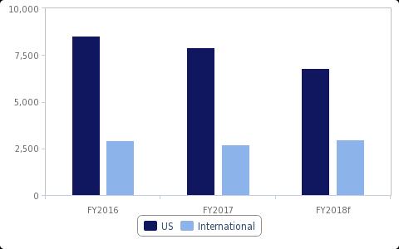
The most productive business of Walmart is the United States business producing net sales of 80.6 billion dollars in the 2019 fiscal year that ended on Oct 26, 2018. Nonetheless, the Company's global segment has been incredibly valuable still and producing net sales of $28.8 billion in that particular, fiscal year quarter. However, the Company has been experiencing major issues overseas. War-Mart is currently undergoing major difficulties in its expansion of the operations majorly in Asia better part of it, specifically in India and China. This is as a result of a section of the major cultural and business problems that might be experienced by a global company in its operation expansion attempts into any foreign nation.
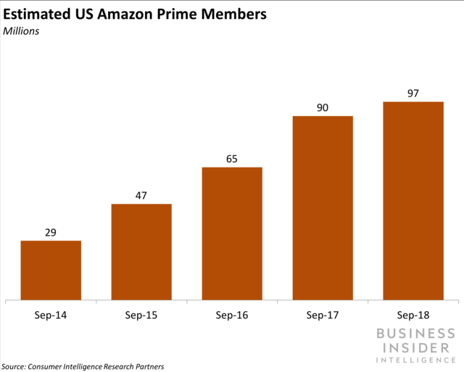
The study elaborates on the global expansion of Wal-Mart and the problems faced in the venture. The study also examines if War-Mart has the likeliness of penetrating the Asian market with its specific retail strategy in the United States Market.
Expansion
Wal-Mark is among the largest retail dealer, in fact, the largest in the United States of America. Its financial endowment is largely recognized across the globe, and the Company perceives that for a global expansion with its rapid rise in revenues above the one for the United States. With this particular notion, Wal-Mart has been exploring diverse markets off late, including the retail market in Asia. However, Wal-Mart seems to lack the information to appreciate that a particular country's success does not automatically guarantee the same success in another given nation. The Company has been pushed by this reality to open other divisions globally within the organization's structures. The responsibility of international growth chances was mandated to the department where the Division was significantly found to cause a fallback stand for the Company in case of a slow down of the United States market. This has facilitated the Company's global penetration in the existing and emerging markets (PURCĂREA, 2017).
The strategy also enhanced the acquisition of shares by the Company in major markets like China. However, the operated stores by Wal-Mart are not established newly since a number of them were attained through acquisitions and joint ventures as well. In Asia, Wal-Mart established the first store in 1996 in China by establishing Supercenter in Shenzhen and Sam’s club. During this particular time, Wal-Mart was boasting the fact that it had penetrated the retail market hub considering Shenzhen as the nation’s front runner of financial reform as well as coastal metropolis top growing. Since then, Wal-Mart has rapidly expanded to other cities in Asia.
The rapid increase in the outlets' number in the Asian nations has been in the Company's strategic strategies. The Wal-Mart top management has steadily informed the significance of the expansion of the company strategies in the global market to the world. They predict for more than a third of the Company's growth in the future will originate from outside the United States' saturating market. Therefore, the Company's international expansion is a long-term objective to develop the global retail market dominance.
Challenges faced in expansion

Cooke et al. 2019, notes that any company faces a wide range of problems in its efforts to expand, ranging from the cultural aspects, stiff competition from similar businesses, and government regulations, among others. This implies that the Company experiences both internal and external challenges. The external challenges are affiliated with the efforts of the Company to the expansion strategies. On the other hand, the internal challenges include the perception of the Company that it is not beatable through competition and therefore ignoring the emerging and existing small competitors whom the particular Company views to lack the potential to dominate the market as it was evidenced in India with Wal-Mart. These particular challenges may act as a hindrance to the expansion of the Company.
The Company continues to receive a wide range of criticisms from individuals and many groups such as the small-town advocates and the labor unions for its business practices and policies and their outcomes. These criticisms vary from discrimination based on gender and race, environmental practices, and others. War-Marts lower prices are criticized for drawing customers away from smaller traders' communities businesses, thus causing nothing better than harm to the local small traders' communities.
In many aspects, the Company ignored the presence of the small traders who were operating the roadside stores. Later, the Company's management realized that it was a real headache to gain the market share that the small traders held as the small traders enjoyed the local community support. It was also noted that the local community ignored and detested the western companies. This, therefore, means it was a real challenge for Wal-Mart to penetrate the Indian market easily. The top management opted to have evaluated the aspect and taken the necessary steps rather than ignoring it. Overturning the local community's huge support to the small traders operating the roadside stores was, therefore, next to an impossibility, thus posing a challenge for the penetration and expansion of Wal-Mart into the Indian market.
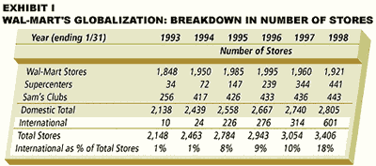
Wal-Mart chances of Success in Asia
Wal-Mart is applying the joint ventures short cut growth and also acquisition in Asia. The employment of the technique is due to the fact that the majority of the government authorities know the challenges that might be presented by the Company if mandated the express autonomy for operating in their nations. The governments seem to be well conversant with the challenges associated with the Company's operation, specifically in foreign nations where the Company seems not to be concerned with the welfare and problems it may cause to the country but majorly driven by its desire to maximize its profits.
Previously, the Company has greatly been accused of gender discrimination, which is a violation of the rights of the majority of the country's citizens, provision of low wages, which in many aspects is considered as a modern form of slavery, strictness with its suppliers as well as the destruction of the small local business because of its financial endowment. In most cases, the Company kills the small available local companies declaring the majority of the citizens employed by these small businesses jobless. Additionally, it poses a challenge in the development of the local innovations and inventions, rendering the country to hugely rely on foreign products and services a case that may result from rising in the exploitation cases and provision of sub-standard or low-quality products as well denying the local consumers an opportunity to enjoy a variety of high-quality products at low prices. Due to these facts, countries like South Korea and ensure they have enhanced strict rules and regulations, thus discouraging foreign investors like Wal-Mart.
This perception of Wal-Mart has the probability of influencing its activities and operations in Asia since the Company is perceived as Western ideologies and government representation aiming to modify Western countries' culture. This implies that War-Mart is perceived as to practice modern colonialization, which the eastern governments and authorities are not ready to give, hence posing a threat to its expansion. Therefore, unless Wal-Mart does a reevaluation of its strategies on international expansion, it might not be easy to excel in the Asian Market.
Cultural Diversity
According to Chuang et al. 2011, the arena of international business is highly faced by the problems of cultural differences. Different nations and regions pose different cultures, which greatly influence any particular international business company, especially where these cultures are not put into consideration. This still holds as one of the greatest obstacles of Wal-Mart in its globalization attempt. The Company's penetration globally is hindered by the cultural difficulties in the various foreign nations of operations. The Company is met with high resistance from the local communities, specifically in the Asian Market, as highlighted above. First, there is a perception among the local communities that the Company is grabbing and encroaching the little available business opportunities for the local small businesses and traders.
In various situations, the local communities have been seen putting more pressure on their authorities to deny the company permission to operate. In this case, the local communities seek to protect their interests through the community dragging in. culture difference is also a responsible determinant for the Company's contention when trying to establish new branches in the retail market in Asia. The community pressure may force the government to work upon it hence disadvantaging the Company's strategic plans for expansion in the particular Asian markets.
The Company's international Division having the mandate to conduct the study in the potential and prospective markets, seems successful in this specific front. However, the Division has failed to set the preferences for the consumers that are influenced in some markets by culture, specifically in most Asian nations. Having adequate information concerning the culture-driven customer preferences and tastes can be a good foundation in establishing a successful prospective market front. This calls for a detailed study of the community culture to understand in which better angle to target the particular market. However, Wal-Mart seems to have ignored this particular fact, which has, as a result, acted as an obstacle for the establishment and expansion of the Company.
According to Michelson et al. 2017, there exist a number of conflicts between the Company and its client, a situation that has forced the Company to approve amendments that will assist it not to close down the operations in its stores. For example, in the context of Asia, Wal-Mart experienced problems upon entering China. Here, the small scall traders where the attendant is the owner generally sell retail products similar to those stocked by Wal-Mart. From this perspective, the locals are conversant, familiar, and free with small-scale retails owners, and they often interact freely. In most cases, the stores are generally dirty, noisy, and packed, although they do operate at low prices. Wal-Mart identified this as a business gap and opportunity and was ready to acquire all the necessary required resources to fill the gap and decided to establish a hypermarket. The Company's particular attempt to introduce the hypermarket concept, which offered clean outlets that were well spaced and salespeople for attending the customers, made the consumers uneasy. The customers didn’t seem to like the particular strategy by Wal-mart and, in most cases, preferred their initial way of shopping. They were typical and used to conduct their shopping in total privacy, where they were only used to dealing with the retail shop owner individually at a time. The approach by Wal-Mart needed the customers to alter the purchasing and shopping anticipations and habits when buying the commodities and products from the stores.
Social relationships in India play a major responsibility in financial deals. The aspect still stands in place, even with the presence of globalization for the communities in India. Nonetheless, Wal-Mart has continued to change this attitude by the community regarding westernization gradually. It has been able to attain an essential customer base with the existence of the small traditional shops. These shops mark the existence of waysides in India. The small traditional markets continue to dominate and control the retail market, and it seems they will continue with the same control and domination to almost eighty-five percent of the local market. These roadside shops may seem to be only slightly larger than a cabinet, but the local consumers highly prefer them. This preference of the local customers' roadside shops is perceived to have been contributed by the high rate of poverty that has pushed the locals to it.
A strong relationship was established between the shop owners and the locals, which even made them qualify for goods on credit whenever they do not have the cash. In contrast with Wal-Mart, the locals would, therefore, enjoy buying and shopping where there was the availability of credit. Wal-Mart did not offer credit facilities to the locals. Considering that the disposable income levels might not rise in the near future, the large retail companies should, therefore, desert their latest plans; thus, the chains should aim to become the neighborhood store.
The set of Laws
When engaging in international trade, it is quite inevitable to consider the laws of the state. In the United States, Wal-Mart is termed as a very powerful investor. In fact, the majority of the market is enjoyed by the Company. This due to its laid strategic plans that have seen it enjoy specific success in the United States. It is evident that most customers enjoy shopping with Wal-Mart compared to other businesses providing the same commodities, especially the small scale retailers. However, in other foreign nations, the Company is classified as an overseas investor whose objective is only to exploit the human and financial resources of a country for its profit maximization but rather not for the particular nation's interests. This particular problem manifested itself upon the entry of the China company, which is densely populated, having a potentially large market. The country has more than a hundred and seventy metropolises. To Wal-Mart company, this was a great potential market for its stores, and it would possibly reap big.
Wal-Mart companies seek to maximize the large potential market. Nonetheless, the restrictive and stringent regulations of the specific communist government regulations hindered the endeavors of the Company. These governments curtail the Company's expansion by setting up restrictions that limit the Company's operations in a specific foreign country. For example, the Company was boxed in specific counties by the Chinese government in order to regulate competition. In this particular case, the Chinese government saw the need to restrain competition among the local companies and Wal-Mart in individual counties to protect the small local retailers from the stiff competition and exploitation since it felt that Wal-Mart had the capacity to do so. Since then, Wal-Mart is yet to establish an outlet or branch in a flourishing city.
For the case of India, the Indian Federal laws hinder international retailers from investing directly in the Indian economy. This implies that global retailers are, in a way, curtailed in thriving and expanding in the Indian economy as it is not mandated to do so. As a result of this policy, War-Mart has been caught a victim of the restrictions, thus forcing the Company to penetrate the vast Indian market through joint ventures. The Indian government is comparatively young concerning the policy infrastructure; hence, the community's norms are embedded deeply onto the mindset of society. Therefore, this is evidence that society's perspective greatly influences the government, and it is the one that determines the policy infrastructure. The investors, who in most cases are the policymakers, control the processes of decision making substantially. They guide the legislation creation, which implies that any decision on legislation processes must be advantageous to them. Owing to that, they are in favor of small scale retailers. These decision-makers are the small trade store owners. Therefore, they will ensure that the business encroachment perceived notion by the global companies flows within the government's structures (Xie & Cooke, 2019).
Local Communities
Wal-Mart's plans of opening a new store location in most cases have to be followed by an equivalent municipal civil war as attempts to force itself way in between the anti and pro Walmart factions. Opponents of the Company majorly highlights the environmental challenges, congestion in the traffic, poor public relations, the safety of the public, low benefits and wages as well as predatory pricing. The opposition by the religious groups, competitors, labor unions, and local individuals may include the destruction of properties in the store buildings, protest marches, or through establishments of bomb scares. Additionally, developers who are planning to incorporate Walmart in their projects are denied permits by the city councils hence posing a challenge in the Company's expansion plans.
Labor concerns overseas
The Company continues to be criticized for failing to avail of its foreign suppliers' adequate supervision. Additionally, it is criticized for using prison labor and sweatshops. For instance, Harry Wu, a Chinese dissident in 1995, charged that the Company contracted prison labor in Guangdong province. In its defense, Walmart denied using prison labor. There have also been reports that the Company recruits teenagers to work for to work eight hours per week in Bangladesh for only 0.14 dollars per hour for Beximco, the company supplier. The low price high cost depicts images of the poor conditions of the Company's commodities producing factories and also the inhumane conditions and abuse that the factories workers are subjected to. Some of these factors and conditions can be termed as the reason why most of the authorities and governments are reluctant to guarantee Walmart's automatic access to their markets as they consider the effects that might be resulted.
The current monitoring process that is used by Walmart is considered inadequate and poses a hindrance to the verification of the conditions by the outsiders. Walmart fails to release its factory names or audits, thus forcing the outside organizations only to accept the claims by Walmart as facts. The Company started to operate with a California based non-profit organized Business for Social Responsibility to reach out to active groups in monitoring factories overseas.
In 2006, the Company got excluded from the Government Pension Fund of Norway investment portfolio, which had stock values in the Company of around $430 million because of the social audit into the labor rights violations in the Company's operations in Africa, Asia, Latin America, Canada as well in the United States.
On Nov 24, 2012, in Bangladesh, a fire in a clothing factory led to the death of a hundred and twelve workers. The survivors of the tragedy claimed that the fire extinguishers failed to operate; the emergency door was locked. When the alarm was off, the workers were instructed by the managers to return to the sewing machines. The victims jumped or trapped to their deaths from the story building, which lacked fire exits or escapes. Having experienced this from other nations, the majority of the governments may find it difficult to allow the Company the rights to take its operations freely as they fear the possible outcomes that may result. The Company has therefore been branded as irresponsible on matters concerning the safety of its workers and employees.
There are currently speculations that the Walmart merger United Kingdom supermarket chain Asda and other chains Sainsbury's might be obstructed because of concerns on competitions. The Company is said to be posing as a major competitor to the local retailers, especially the small local traders. The strategy was initially highlighted in April 2018 and would see Walmart claim a share of 42% in the new Company to be established and receive approximately $4.1 billion. This implies that Walmart would be entitled to a non-cash loss of approximately $2 billion. It would also be forced to take a step back from the grocery market, which is considered highly competitive.
In reference to the Wall Street Journal, Walmart might be capable of finding a private equity buyer if the deal is done, although this would force it to reconsider its United Kingdom presence future. Flipkart, where Walmart company had invested $billion in, has to withstand the Indian rules and regulations that are targeting the e-commerce business companies having foreign investors. The new regulations on foreign direct investment affect the abilities of the companies such as Flipkart to provide excessive commodities and discounts and sell goods via companies that own a section of. Flipkart might survive the changes and still thrive probably. However, for Walmart's case, the Company should surely prefer not to face new problems that have modifications to the high-value market it made like the massive investment in.
Technological challenges
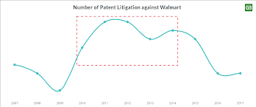
Like any other international company, Walmart is experiencing technological challenges in most foreign nations, especially in Africa and Asia. Most countries in the two continents have not developed technical wise to meet the required expectations. In most cases, these countries' technological advancement is no near the one for the United States and the United Kingdom. In most cases, international companies may find it challenging to carry out their operations with ease, as it would be the case where technology has dramatically developed. Technological challenges can be linked to the low rates of establishments, penetration, and dominance of Walmart in the majority of the foreign nations.
Conclusion
These challenges that hinder Walmart's expansion in the international markets need to be reevaluated and sorted out for a better share of the Company in the international market. Working out these issues will be crucial for Walmart's future rivalry with Amazon. Walmart's desire to put more emphasis on foreign markets has high potentials, such as India, instead of those where competition is already high such as Brazil and the United Kingdom. However, these efforts are becoming complicated due to the various associated challenges that are hindering its dominance and expansion in the foreign markets.
Similar to Walmart's cases, other companies such as Amazon have also invested heavily in the global markets and continues to strategize on the expansion in the foreign markets. The strategy is essential to the two companies since, even if the North American market is valuable incredibly, it is already highly competitive. Additionally, it provides lower rates of growth compared to most of the emerging markets. However, the main determinant for the penetration and expansion in these new markets is determined by how keen every Company is in establishing its strategies and evaluating the various obstacles presented in the foreign markets. How the Company also carries its operations majorly considering the cultural factors.
Considering the case for Amazon specifically, the global markets are required to boost progress for the major subscriber base, which is proceeding towards saturation. For Walmart to excel in high markets of high growth, specifically the ones that Amazon is in or has interests in, Walmart will be required to thrust its businesses and operations to better and new heights with Amazon in the upcoming days. Therefore, Walmart is required to up its games to establish itself, penetrate, and dominate these foreign markets.
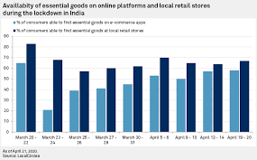

References
Chuang, M. L., Donegan, J. J., Ganon, M. W., & Wei, K. (2011). Walmart and Carrefour's experiences in China: resolving the structural paradox. Cross-Cultural Management: An International Journal.
Cooke, F. L., Liu, M., Liu, L. A., & Chen, C. C. (2019). Human resource management and industrial relations in multinational corporations in and from China: Challenges and new insights. Human Resource Management, 58(5), 455-471.
Hunt, I., Watts, A., & Bryant, S. K. (2018). Walmart’s international expansion: Successes and miscalculations. Journal of Business Strategy.
Michelson, H., Boucher, S., Cheng, X., Huang, J., & Jia, X. (2017). Connecting supermarkets and farms: The role of intermediaries in Walmart China’s fresh produce supply chains. Renewable Agriculture and Food Systems, 33(1), 47-59.
PURCĂREA, T. (2017). Competing in today’s challenging retail environment.
Xie, Y., & Cooke, F. L. (2019). Quality and cost? The evolution of Walmart's business strategy and human resource policies and practices in China and its impact (1996–2017). Human Resource Management, 58(5), 521-541.

